Empirical formula – Magnesium Oxide
Below is data collected in an experiment investigating the empirical formula of Magnesium oxide.
Table 1. Reaction of Mg_{(s)} + O_{2(g)} → Mg_{x}O_{y(s)}
Mass of Crucible with lid | 676.54 grams
Mass of Mg reacted | 0.18 grams
Mass of crucible, lid, and magnesium oxide | 676.84 grams
Mass of Magnesium Oxide | 0.30 grams
Mass of Oxide

- Determine the mass of Oxide missing from the table. (1 mark)

- Determine the empirical formula of Magnesium oxide using this data. Show all your working (2 marks)

- Determine the mass of Magnesium that would need to be reacted in order to produce 1.0 grams of oxide.

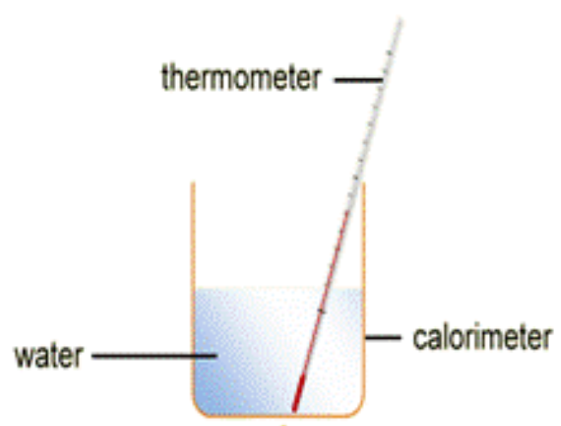
Calorimetry
A simple calorimeter was set up as shown in the diagram below. The calorimeter was filled with 250 mL of a 1.0 M solution of Iron Chloride (FeCl₂), and the temperature was recorded. A small piece (1.5 grams) of calcium metal was added to the calorimeter, and the temperature was recorded every 30 seconds for 15 minutes.
The reaction which occurred was
Ca_{(s)} + FeCl_{2(aq)} → CaCl_{2(aq)} + Fe_{(s)}
The following tablke shows the data collected over the 15 minutes of the experiment
Time (min) | 0.5 | 1.0 | 1.5 | 2.0 | 2.5 | 3.0 | 3.5 | 4.0 | 4.5 | 5.0 | 5.5 | 6.0 | 6.5 | 7.0 | 7.5 | 8.0 | 8.5 | 9.0 | 9.5 | 10 |  | 11 |  | 12 |  | 13 |  | 14 |  | 15
Temp  (⁰C) | 25 | 28 | 31 | 34 | 36 | 38 | 39 | 40 | 40 | 39 | 39 | 38 | 39 | 38 | 37 | 37 | 36 | 36 | 36 | 35 | 35 | 34 | 34 | 33 | 32 | 32 | 31 | 30 | 30 | 29

- Determine the temperature change caused by the reaction. Identify if this was an increase or decrease in temperature. (2 marks)

- Identify the reaction as exothermic or endothermic. Justify your answer using data from the question. (2 marks)

- Calculate the change in Enthalpy for the reaction in kJ/mole, assuming that the calcium metal is the limiting reactant. (3 marks)

- Do you consider it likely that the answer to question 3 (the change in enthalpy value) is accurate? Justify your answer using evidence from the question.

Successive Ionisation energies
Below is a graph of the first 14 successive ionisation energies of Chlorine.
- Identify the log value of the 5th ionisation energy. (1 mark)

- Describe the trend between ionisation number and log value for successive ionisation energy (1 mark)

- a. How many electrons are in the valence shell of this atom? Explain your answer using data from the graph. (2 marks)

- Identify the shell number and subshell from which it is easiest to remove an electron from chlorine.

- Compare the ionisation energies of the outermost shell of chlorine to the ionisation energy of the next shell.

- Predict the log value of the ionisation energy of the 15th electron lost by Chlorine

- Identify the evidence in the graph that conclusively identifies this element as Chlorine. Explain using evidence from the graph to support your answer.

Periodic trends
Below are graphs of two key periodic trends – atomic radii and first ionisation energy.
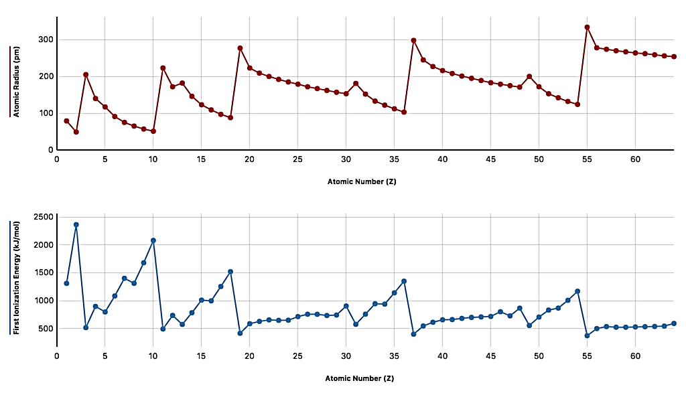
- Identify a trend between
- atomic number and Atomic radii (1 mark)

- Atomic number and first ionisation energy (1 mark)

- Atomic radii and first ionisation energy (1 marks)

- Identify the group of the periodic table which has the highest atomic radii? (1 mark)

- Identify the group of the periodic table which has the highest first ionisation energy? (1 mark)

- Compare the first ionisation energy of the element with an atomic number of 15 to the first ionisation energy of the element with an atomic number of 7. (3 marks)

